**Practical – 3**

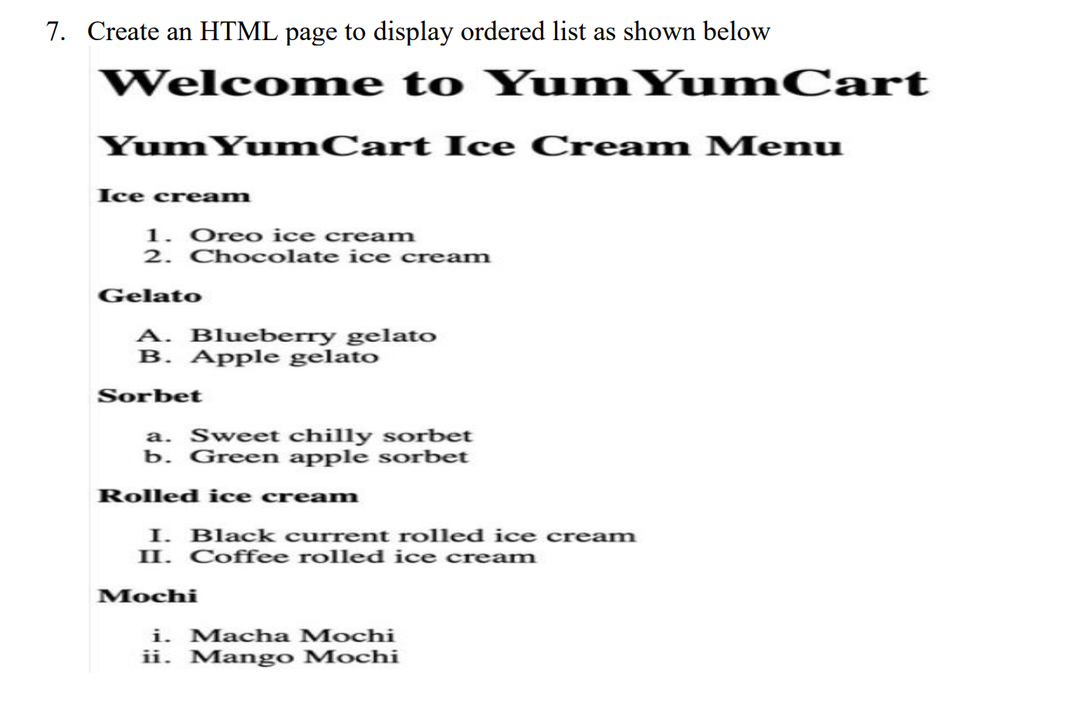

**HTML Code**

<!DOCTYPE html>

<html lang="en">

<head>

<meta charset="UTF-8">

<meta name="viewport" content="width=device-width, initial-scale=1.0">

<title>Rowspan & Colspan </title>

</head>

<body>

<h1>Welcome to YumYumCart</h1>

    <h2>YumYumCart Ice Cream Menu</h2>

    <h3>Icecream</h3>

    <ol type="1">

        <li>Oreo ice cream</li>

        <li>Chocolate ice cream</li>

    </ol>

    <h3>Gelato</h3>

    <ol type="A">

        <li>Blueberry Gelato</li>

        <li>Apple Gelato</li>

    </ol>

    <h3>Sorbet</h3>

    <ol type="a">

        <li>Sweet chilly sorbet</li>

        <li>Green apple sorbet</li>

    </ol>

    <h3>Rolled Ice cream</h3>

    <ol type="I">

        <li>Black current rolled ice cream</li>

        <li>Coffee rolled ice cream</li>

    </ol>

    <h3>Mochi</h3>

    <ol type="i">

        <li>Macha Mochi</li>

        <li>Mango Mochi</li>

    </ol>

</body>

</html>

**Output**

